Supply & Demand Zone

Last candle before the impulsive move with an imbalance is the zone of interest.

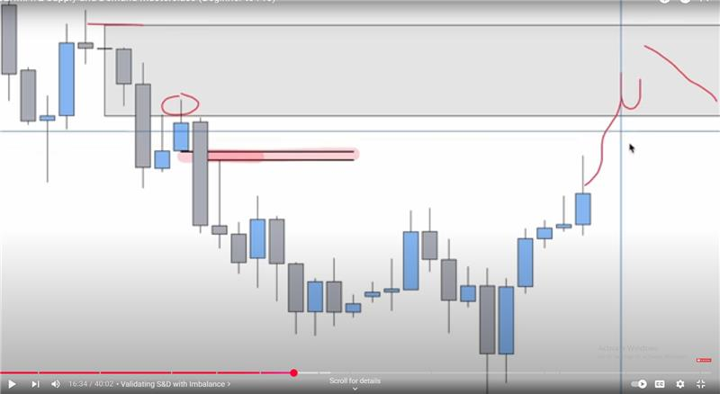

Extreme zone is the supply or demand zone which is the most further from the current price. Extreme zone is most of the time most probable and most profitable.

If you have multiple zones clustered very near to each other. At these points selecting which zone to select could be done through the NHS strategy.

Second way of confirming if the price will hold the area. Price created a demand zone and moved away, Now we are waiting for it to return to the demand zone, but while coming to the demand it was moving in a bearish pattern we wait for the Break of structure near the demand zone and trade with another zone as formed in the picture above.

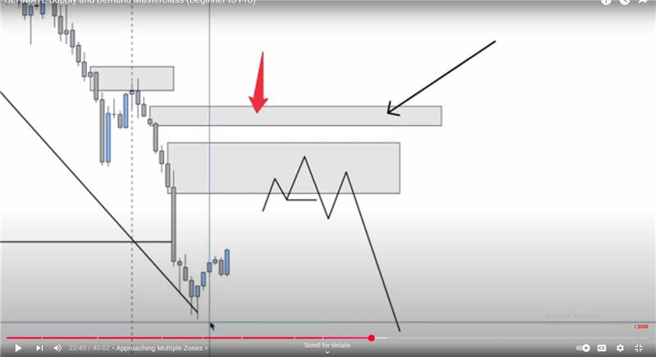

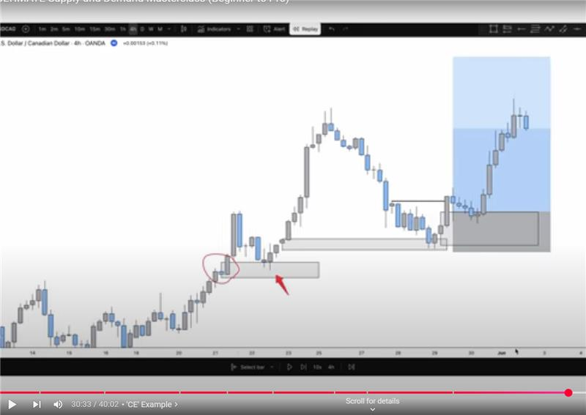

Which zone will hold in the multiple ones that are present at the moment.

Look for these things in the order:

Inefficieny/ Imbalance

Extreme zone

Momentum

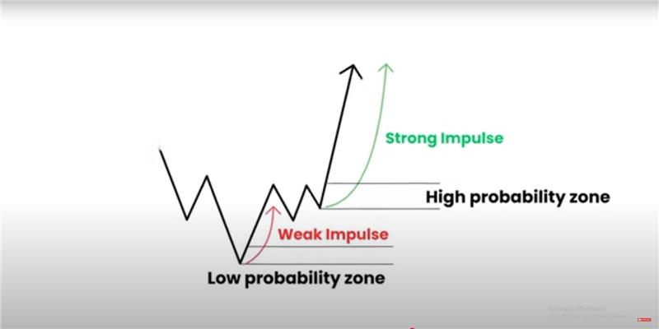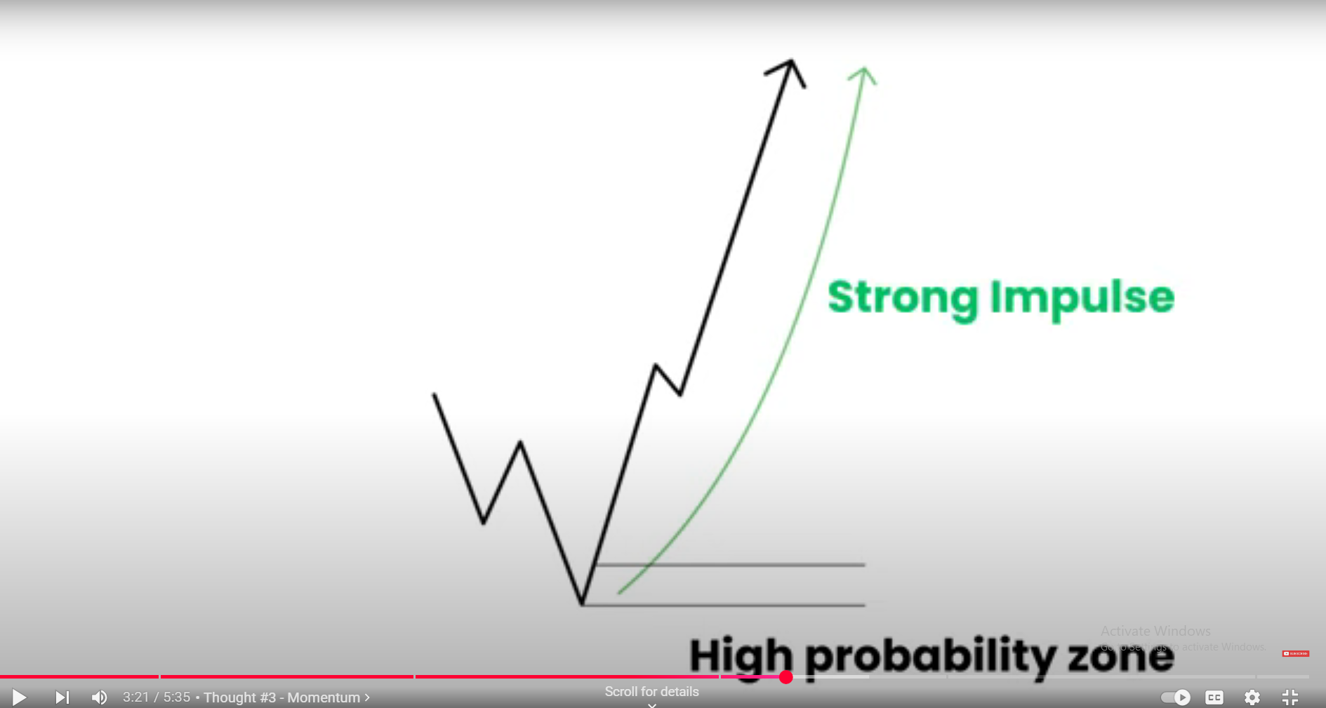

Confirmation from the higher time frame.